School of Computing Science and Engineering
B.Tech (CSE)
Subject: Computer Networks Lab
NS2 Lab Manual

Part of Introduction to TCP/IP model

Application Layer | CBR FTP, telnet….
Transport layer | TCP,UDP
Network layer | rtproto
Data link Layer | Transmission mode  - Simplex mode  - Duplex mode
Physical layer

Application Layer
Applications agents are Telnet, FTP, Rlogin, CBR
Transport Layer
The transport layer uses two protocols, UDP and TCP. UDP which stands for User Datagram Protocol does not guarantee packet delivery and applications which use this must provide their own means of verifying delivery.
TCP does guarantee delivery of packets to the applications which use it.
Network Layer
The network layer is concerned with packet routing and used low level protocols such as ICMP, IP, and IGMP. Here Network protocols are omitted for simple examples
Link Layer
The link layer is concerned with the actual transmittal of packets as well as IP to Ethernet address translation. Data transfer in two modes i.e. simplex mode and in duplex mode.
Where can you write Scripts?

After login into terminal, follow step given below
1. vi filename.tcl
It will open page, there you can write tcl scripts.
2. save file
Press esc-> colon (shift + semicolon) ->wq (save and quit)
It save the file
3. To run tcl script
ns filename.tcl

Basically NS 2 programming contains the following steps.

1. Create the event scheduler
2.Turn on tracing
3.Creating network
a) Computing setup routing - rtproto
b) Creating transport connection-Agents
c) Creating traffic-Applications
4. Monitoring
a) Visualization using nam
b) Tracing using trace file

Template

Every ns2 script starts with creating simulator object
set ns [new Simulator]

How to create node
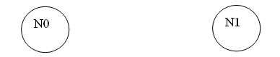
set n0 [$ns node]
set n1 [$ns node]

Creating link
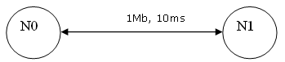
$ns duplex-link $n0 $n1 1Mb 10ms DropTail

This line tells the simulator object to connect the nodes n0 and n1 with a duplex link with the bandwidth.1Megabit, a delay of 10ms and a DropTail queue.

How to use Trace?
We use simulator to see results. How is it achieved? Using trace
Two types of trace
1. generic trace
for use with xgraph, and other things
2. nam trace
for use with visualization
# open trace file

set tracefile [open out.tr w]
$ns trace-all $tracefile
#Open the nam trace file
set nf [open out.nam w]
$ns namtrace-all $nf

set n0 [$ns node]
$ns duplex-link $n0 $n1 1Mb 10ms DropTail

Since we have started tracing, we should end also. For this we use finish procedure.
#Define a 'finish' procedure
proc finish {} {
global ns tracefile nf
$ns flush-trace
close $nf
close $tracefile # close tracefile
exec nam out.nam & #Execute nam on the trace file
exit 0
}
Finish procedure is forced to be called at the end with the line
$ns at 5.0 “finish”
Every tcl script must contain following statement
$ns run

Golden rules

All communication between 2 agents.
Upper layer to lower layer, we attach agents.
Same layer in two nodes, we connect agents.
Agents are tcp, udp, telnet, cbr…etc

UDP communication
In UDP communication, data is flows from UDP agent to Null agent.
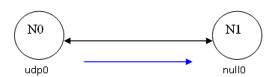
#Create a UDP agent and attach it to node n0
set udp0 [new Agent/UDP]
$ns attach-agent $n0 $udp0
# create a null agent which act as traffic sink and attach it to node n1
set null0 [new Agent/Null]
$ns attach-agent $n1 $null0
# connect two agents with each other
$ns connect $udp0 $null0

Traffic generator
For actual data to flow, we need traffic generators. They simulate some application traffic.
Simple example using CBR
# creating CBR agent
set cbr0 [new Application/Traffic/CBR]
# Attach the CBR agent to some udp/tcp agent
$cbr0 attach-agent $udp0
Scheduling the events
Here “at” place major role.
$ns at 1.0 “$cbr0 start”
$ns at 4.0 ”$cbr0 stop”
TCP Communication
In TCP communication, data is flows from TCP agent to TCPsink agent.
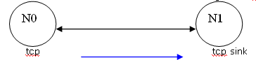
# create Tcp agent and attach it to node no
set tcp0 [new Agent/TCP]
$ns attach-agent $n0 $tcp0
# create a tcpsink agent which act as traffic sink and attach it to node n1
set tcpsink0 [new Agent/TCPSink]
$ns attach-agent $n1 $tcpsink0
# connect two agents with each other
$ns connect $tcp0 $tcpsink0
Traffic generator

For actual data to flow, we need traffic generators. They simulate some application traffic.
Simple example using FTP
# creating FTP agent
set ftp0 [new Application/FTP]
# Attach the CBR agent to some udp/tcp agent
$ftp0 attach-agent $tcp0
Scheduling the events
Here “at” place major role.
$ns at 1.0 “$ftp0 start”
$ns at 4.0 ”$ftp0 stop”
Simple Example

CBR over UDP

set ns [new Simulator] |  | Creating simulator object
set tracefile [open out.tr w]  $ns trace-all $tracefile |  | Open trace file
set nf [open out.nam w]  $ns namtrace-all $nf |  | Open the nam trace file
proc finish {}  {  global ns tracefile nf  $ns flush-trace  close $nf  close $tracefile  exec nam out.nam &  exit 0  } |  | 'finish' procedure
set n0 [$ns node]  set n1 [$ns node]  $ns simplex-link $n0 $n1 1Mb 10ms DropTail |  | Create your topology  - set n0 nodes….  - $ns duplex-links…
set udp0 [new Agent/UDP]  $ns attach-agent $n0 $udp0  set cbr[new Application/Traffic/CBR]  $cbr attach-agent $udp0  set null0 [new Agent/Null]  $ns attach-agent $n1 $null0  $ns connect $udp0 $null0 |  | Create your agents  -transport layer and application layers stuff
$ns at 1.0 "$cbr start"  $ns at 3.0 "finish" |  | Scheduling Events  - $ns at 1.0 start  and at 3.0 finish
$ns run |  | starts the simulation.

Result

Before 1.0ms

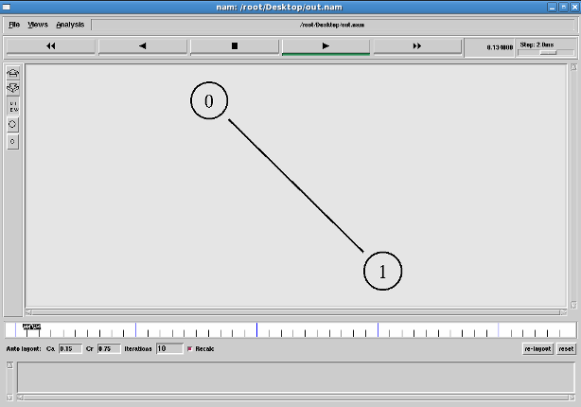

After 1.0ms

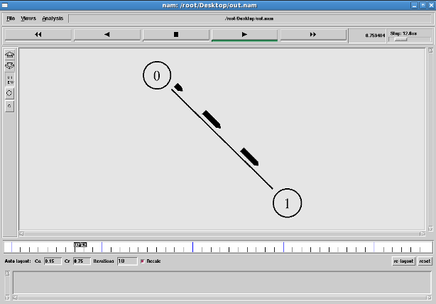
FTP over TCP

set ns [new Simulator] |  | Creating simulator object
set tracefile [open out.tr w]  $ns trace-all $tracefile |  | Open trace file
set nf [open out.nam w]  $ns namtrace-all $nf |  | Open the nam trace file
proc finish {}  {  global ns tracefile nf  $ns flush-trace  close $nf  close $tracefile  exec nam out.nam &  exit 0  } |  | 'finish' procedure
set n0 [$ns node]  set n1 [$ns node]  $ns simplex-link $n0 $n1 1Mb 10ms DropTail |  | Create your topology  - set n0 nodes….  - $ns duplex-links…
set tcp0 [new Agent/TCP]  $ns attach-agent $n0 $tcp0  set ftp0 [new Application/FTP]  $ftp0 attach-agent $tcp0  set tcpsink0 [new Agent/TCPSink]  $ns attach-agent $n1 $tcpsink0  $ns connect $tcp0 $tcpsink0 |  | Create your agents  -transport layer and application layers stuff
$ns at 1.0 "$ftp0 start"  $ns at 3.0 "finish" |  | Scheduling Events  - $ns at 1.0 start  and at 3.0 finish
$ns run |  | starts the simulation.

Result:
Here we are using FTP Application agent as a traffic generator instead of CBR. The difference is CBR traffic generator will produce constant bit rate where as FTP traffic generator produces maximum available bit rate.
We are writing code
set ftp0 [new Application/FTP]
$ftp0 attach-agent $tcp0
and Similarly for telnet also
set telneto [new Application/TELNET]
$ftp0 attach-agent $telnet0
Before 1.0ms

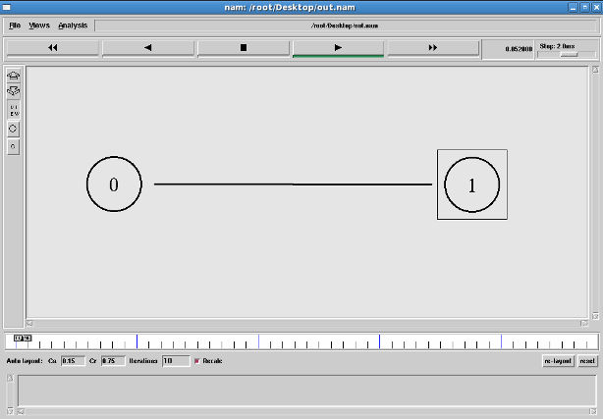

After 1.0ms

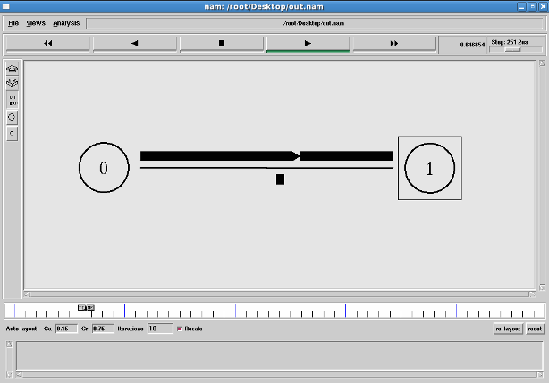
TRACE FILE
When using trace-all in NS2, a trace string is created in a trace file. The trace file would look like this.

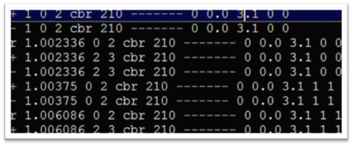

Trace file format
The format of a trace string is shown below:
where 12 fields of the trace string are as follows.
1. Type Identifier:
- “+”: a packet enque event
- “-”: a packet deque event
- “r”: a packet reception event
- “d”: a packet drop (e.g., sent to dropHead_) event
- “c”: a packet collision at the MAC level
2. Time: at which the packet tracing string is created.
3-4. Source Node and Destination Node: denote the IDs of the source and the destination nodes of the tracing object.
5. Packet Name: Name of the packet type
6. Packet Size: Size of the packet in bytes.
7. Flags: A 7-digit flag string
- “-”: disable
- 1st = “E”: ECN (Explicit Congestion Notification) echo is enabled.
- 2nd = “P”: the priority in the IP header is enabled.
- 3rd : Not in use
- 4th = “A”: Congestion action
- 5th = “E”: Congestion has occurred.
- 6th = “F”: The TCP fast start is used.
- 7th = “N”: Explicit Congestion Notification (ECN) is on.
8. Flow ID
9-10. Source Address and Destination Address: the format of these two fields is “a.b”, where “a" is the address and "b" is the port.
11. Sequence Number
12. Packet Unique ID

Cycle sheet-2

1. Simulate a three nodes point — to — point network with duplex links between them. Set the queue size and vary the bandwidth and find the number of packets dropped.

Create the event scheduler
Turn on tracing
Creating network
a) Create your topology
Vary the Bandwidth
b) Creating transport connection-Agents
c) Creating traffic-Applications
Set the queue size
# set the queue size b/w the nodes
$ns set queue-limit $n0 $n2 10
Monitoring
a) Visualization using nam
Calculate the no. of packets dropped
awk script used for calculating the no. of packets dropped from your trace file
To run the awk script in Linux,
awk –f filename.awk filename.tr

2. Simulate a four node point-to-point network with the links connected as follows:
n0-n2, nl-n2 and n2-n3. Apply TCP agent between n0-n3 and UDP between nl-n3. Apply relevant applications over TCP and UDP agents changing the parameter and determine the number of packets sent by TCP/UDP.

Create the event scheduler
Turn on tracing
Creating network
a) Create your topology
b) Creating transport connection-Agents
c) Creating traffic-Applications
Monitoring
a) Visualization using nam
Calculate the no. of packets sent by TCP/UDP

3. Simulate the transmission of ping messages over a network topology consisting of 6 nodes and find the number of packets dropped due to congestion.

Create the event scheduler
Turn on tracing
Creating network
a) Create your topology
b) Creating transport connection-Agents (ping)
c) Creating traffic-Applications
d) The below function is executed when the ping agent receives a reply from the destination

Agent/Ping instproc recv {from rtt}
{ $self instvar node_
puts " The node [$node_ id] received an reply from $from with round trip time of $rtt"
}
Monitoring
a) Visualization using nam

Calculate the no. of packets dropped due to congestion.

